For getting latest updates in code
- Go to C: Drive
- Go to xampp folder
- Go to htdocs folder
- Go to llcfapp folder
- Right click select TortoiseGit Click on first option pull
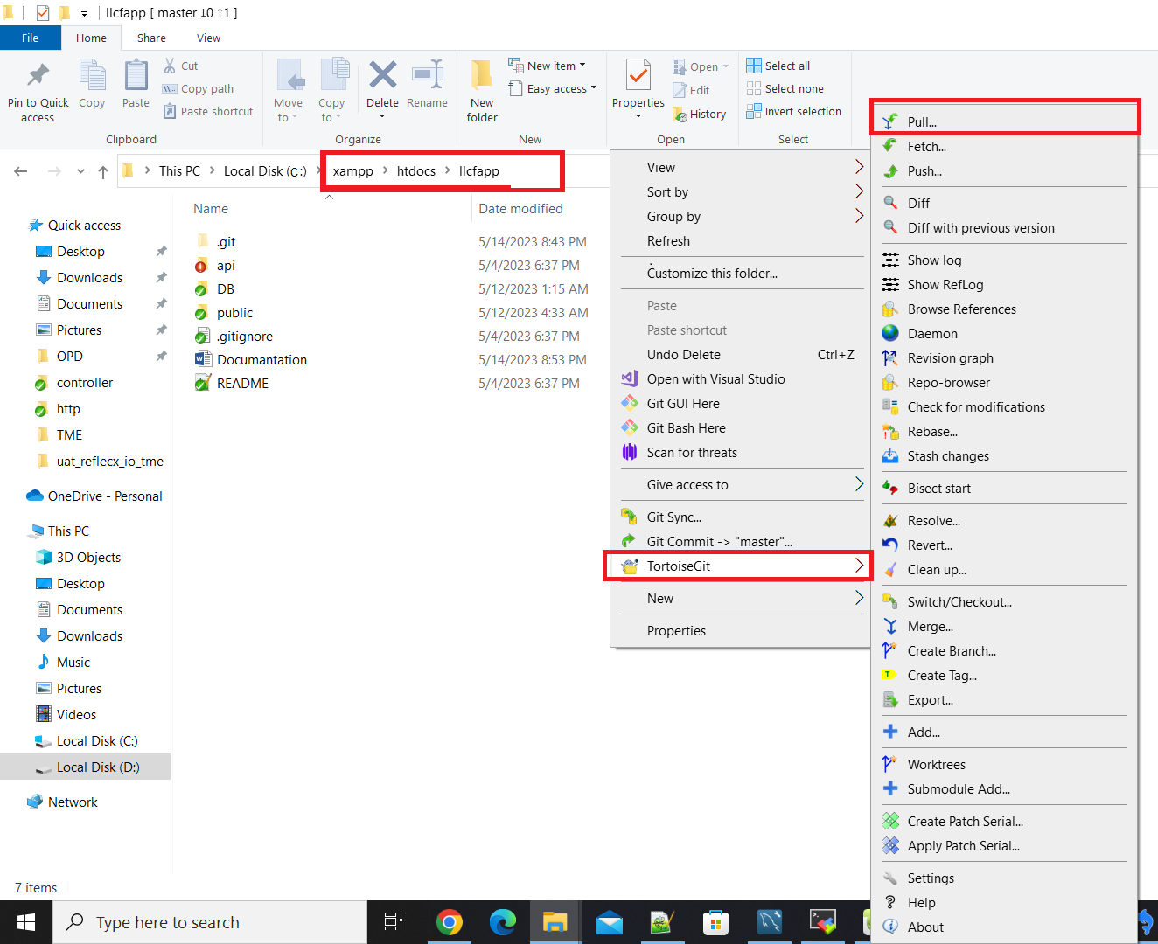

For Running Project
- Search xampp in windows search
- Open control panel
- Click on start next to Apache | When it turns green you are ready to go
